Quiz - Week 5: Thermodynamics
Questions 1-4 refer to the following Diagram.
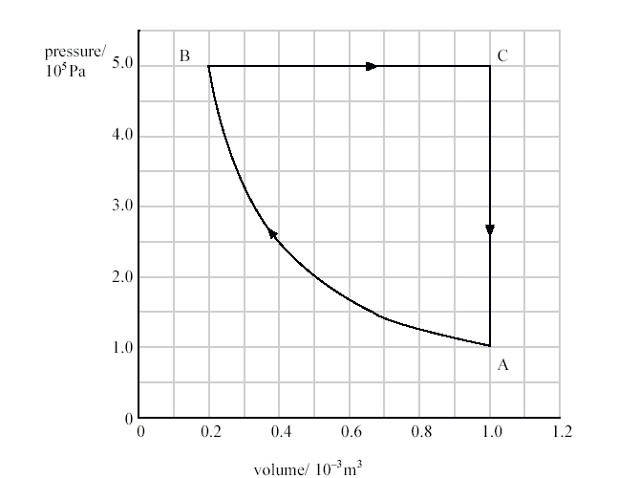

- In which process is no work done?
  - A®B
  - B®C
  - C®A
  - B®C®A
  - A®B®C®A

- The temperature of the gas at point A is 200K. What is the approximate number of molecules in the container?
  - 3 x 10²² molecules
  - 3 x 10²⁰ molecules
  - 6 x 10⁻² molecules
  - 3 x 10⁻²³ molecules
  - It is impossible to tell with knowing the molar mass of the gas.

- If the temperature at point A is 200K, What is the temperature of the gas at point C?
  - 8 K
  - 40 K
  - 250 K
  - 500 K
  - 1000 K

- What is the work done in the process B®C?
  - 0 J
  - 4 J
  - 8 x 10² J
  - 2 x 10³ J
  - 4 x 10³ J

- The specific heat of iron is approximately 450 J/kg°C. If 27,000J are used to heat a mass of iron from 5°C to 25°C, what is the mass of the Iron?
  - 1 kg
  - 2 kg
  - 3 kg
  - 4 kg
  - 5 kg

- The specific heat of Aluminum is approximately twice the specific heat of iron. Two cups have an identical amount of water in them at the same temperature. A small ball of aluminum and a small ball of iron, both of the same mass, are heated to a temperature of 90°C. The balls are then dropped into the cups of water, one in each cup. 30 seconds after the balls are dropped, the temperature of the water will be greater in which cup?
  - The cup with the aluminum ball.
  - The cup with the steel ball.
  - Both cups of water will be at the same temperature.
  - It is impossible to tell without knowing the initial temperature of the water.
  - It is impossible to tell without knowing the mass of the water in each cup.
- Suppose you are cooking spaghetti for dinner, and the instructions say “boil pasta in water for 10 minutes.” To cook spaghetti in an open pot with the least amount of energy, what should you do?
  - Turn up the burner to its fullest so the water vigorously boils.
  - Turn down the burner so the water barely boils.
  - Add salt to the water, which increases the boiling point of the water.
  - Ensure there is maximum ventilation above the pot of water.
  - Add a layer of olive oil to the pasta water, which will increase the pressure on the water.

Questions 8-9 refer to the following graph

- A 1kg sample of H₂O is placed in a 1000 W microwave. What is the best explanation for segment D of the above graph?
  - Ice is melting, absorbing energy from the microwave as the latent heat of fusion.
  - Water is freezing, releasing energy into the microwave as the latent heat of fusion.
  - Water is boiling, absorbing energy as the latent heat of vaporizaiton.
  - Steam is condensing, releasing energy as the latent heat of vaporization.
  - The temperature of the water is increasing as it absorbs energy according to its specific heat.

- In which segment of the graph is the H₂O in its liquid state?
  - A
  - B
  - C
  - D
  - It cannot be determined

- A heat engine has a hot reservoir of temperature T_{H} = 400°C, and a cold reservoir of T_{C} = 200°C. What is the maximum possible efficiency of the engine?
  - 200%
  - 100%
  - 70.3%
  - 50%
  - 29.7%

